Auth EP Demo Deployment

Server

Requirements

- IIS
- .NET 3.0 (cardspace)
- Asp.net 2.0 (run C:\WINDOWS\Microsoft.NET\Framework\v2.0.50727\regiis.exe –i)
- AuthEPInstallComponent
- AuthEPSTS
- IDPWebsite
- RPWebsite
- RP2Website
- Password if asked in any step during installation is: authep

Installation

Install certificates:
Run certificateconsole.msc

Certificates – Current User:
Import to ‘trusted root certification authorities’: www.auth-ep.nl-server.pfx
Certificates – (Local Computer)
Import to ‘trusted root certification authorities’: www.auth-ep.nl-server.pfx
Import to ‘personal’: www.auth-ep.nl-server.pfx

Enable read access for the certificate:
- launch WseCertificate3.exe
- select ‘local computer’ from the top combobox
- select ‘Trusted Root Certification Authorities’ from the bottom combobox
- select ‘open certificate’
- select the www.authep.nl certificate
- select ‘view private key files properties’
- goto the security tab
- add read access for user ASPNET

install-authep-server.cmd:
Edit install-authep-server.cmd:
- Replace every occurrence of ‘127.0.0.1’ with the IP address of your server.
- Replace path-to-idp-website with the path to the IDP website. Do the same for path-to-rp-website and path-to-rp2-website

Execute install-authep-server.cmd (select yes when asked if you want to install a certificate)

Edit ‘AuthEPSTS.exe.config’ and set BACStore value to <pathtoidpwebsite>\Bac

Configure IIS:
Grant user ASP.NET read and write permissions to the App_Data, BAC and Cards folder in the IDPWebsite folder.

Install certificate in IIS:
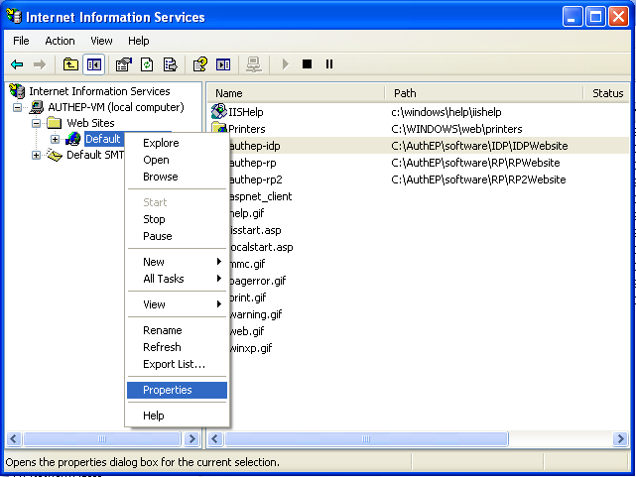

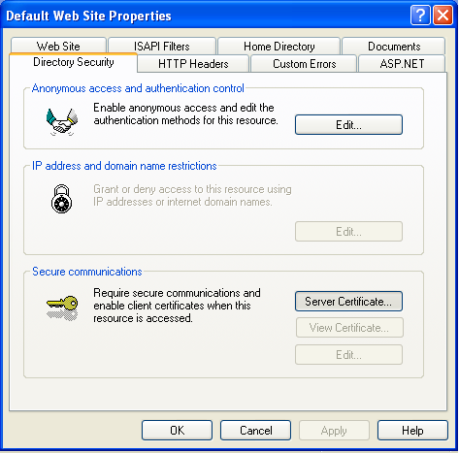

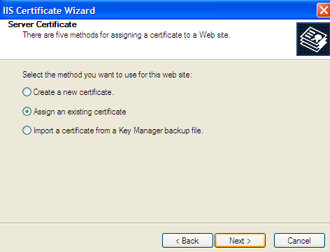

Select www.authep.nl and press next a few times.

Run: tools\https-setup.bat

Client

Requirements

- Java Runtime (tested with v1.6+)
- Compatible RFID reader (tested with OMNIKEY CardMan 5321)

Installation

Execute install-authep-client.cmd

Demo walkthrough

Enrollment
- Goto: https://www.authep.nl/authep-idp
- Fill in Document Number, Date of Birth and Date of Expiry as found on the passport
- Press ‘Create Card’, Open and import the received Managed Card

Using digital passport
- Goto: https://www.authep.nl/authep-rp (or https://www.authep.nl/authep-rp2 )
- Enable any pop-ups from authep.nl
- Place your passport on the RFID reader. (red dot should turn green)
- Press ‘Verify’

